LOGIN AUTENTICATION PAGE

A MINI PROJECT REPORT

*Submitted by*

Group/Team No: G4/team 14

Aryan Gupta: 2210991380

Aryan Gupta: 2210991381

Aryan Kaushal: 2210991382

Aryan Pathania: 2210991383

BACHELEOR OF ENGINEERING

*in*

COMPUTER SCIENCE & ENGINEERING

Subject=FEE-I(22CS004)



CHITKARA UNIVERSITY

CHANDIGARH-PATIALA NATIONAL HIGHWAY

RAJPURA (PATIALA) PUNJAB-140401

April/2023

CONTENT

|  |  |  |
| --- | --- | --- |
| 1. | Introduction | 1 |
| 2. | Problem Statement | 2 |
| 3. | Technical Details | 3 |
| 4. | Key features | 4 |
| 5. | Advantages | 5 |
| 6. | Code With Output | 7-8 |
| 7. | Conclusion with future scope | 9 |

1

INTRODUCTION

Any web application or system that requires user authentication must have a login authentication page. Since the login page is the first place users go to access their accounts or the system, it is crucial to make sure it is trustworthy and secure. The login authentication page and its implementation are described in general terms in this report file, along with the features, security precautions, and performance of the page.

2

PROBLEM STATEMENT

The problem statement of a login autentication page refers to the issue or challenge that the login autentication is designed to address. The aim here is to design and build login autentication page that can make users go to access their accounts or the system . Users can submit their login, password, or other types of credentials, which are checked against a database or authentication service, before entering them. In order to increase security, the website will also have features like password reset, two-factor authentication, or social login options.

3

TECHNICAL DETAILS

* Built using HTML and CSS. HTML(Hyper Text Markup Language) is used to create the structure and content of web pages. CSS (Cascading Style Sheets) is a style sheet language used to describe the presentation and layout of web page.
* HTML files contain content and structure of each page.
* CSS files will control appearance and layout of the pages.
* Header, footer, content area, forms are basic structures of our login authentication page which are created using HTML.
* CSS media queries is used to create attractive website, this makes login authentication page look elegant and different from other.

4

KEY FEATURES:

* User identification: Users must be able to input their username or email address on the login page to be able to access their accounts in the system.
* Password field: A password field where users can input their password is required on the login page. In order to prevent unauthorised users from seeing the password, the password field needs to be hidden.
* Remember me: Users can continue to remain logged in even after they close their browser by using the "remember me" function. This feature is optional, and the user must turn it on.
* Password forgotten? :The "forgot password" feature enables users to change their password. This function often includes emailing the user's email address a link to reset their password.

5

ADVANTAGES

* **Security**: The login page provides users with secure access to their accounts or system. By requiring users to enter their username and password or other identifying information, the login page verifies the user's identity and ensures that only authorized users can access the system.
* **Personalization**: The login page allows users to customize their experience in the system. By logging in, users can access their saved settings, preferences or information and customize their user experience accordingly.
* **Accountability**: The login page ensures accountability by tracking the user's login activity. By recording a user's login history, including date, time and location, the system can detect suspicious activity or unauthorized access and take appropriate action.
* **Collaboration** : The login page enables collaboration by allowing multiple users to access the system simultaneously. By creating individual user accounts, the system can separate users from each other and provide each user with their own personalized user experience.
* **Customization**: On the login page, administrators can customize the user experience based on the user's role, access level, or other criteria. This customization allows for a more efficient and effective system. Compliance: The login page helps organizations comply with regulations, rules or industry standards related to data protection and user authentication. By implementing secure login methods, organizations can ensure that user information is protected and access to sensitive information is controlled.

6

Code:

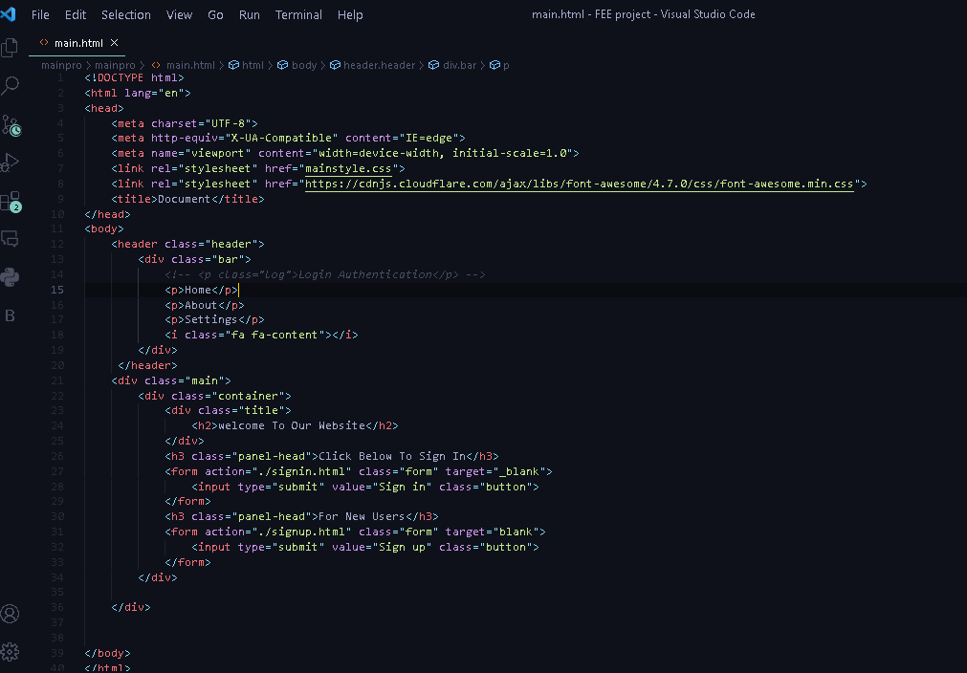

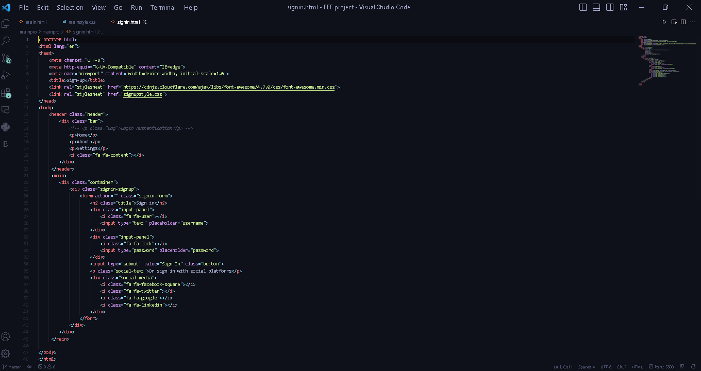 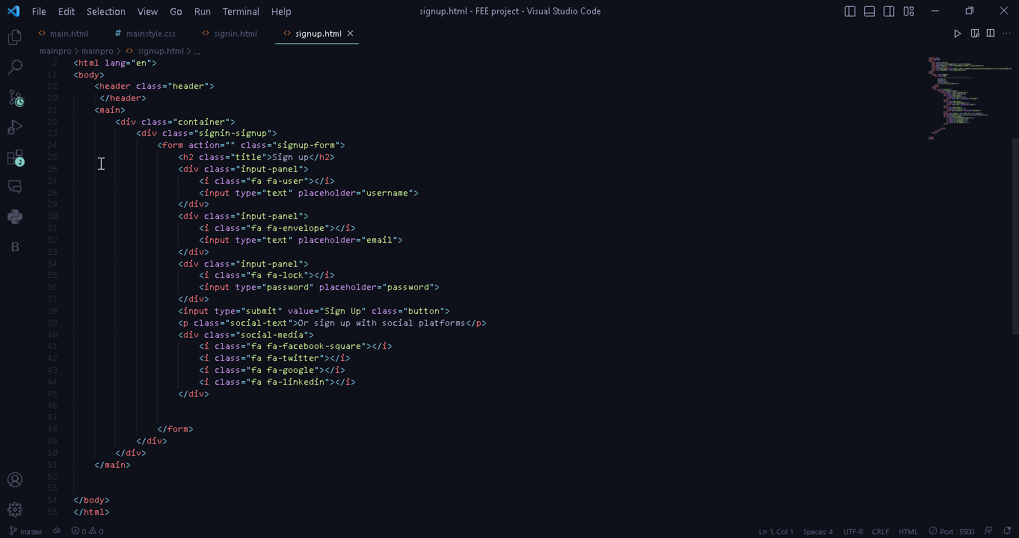

7

OUTPUT:

**MAIN PAGE**

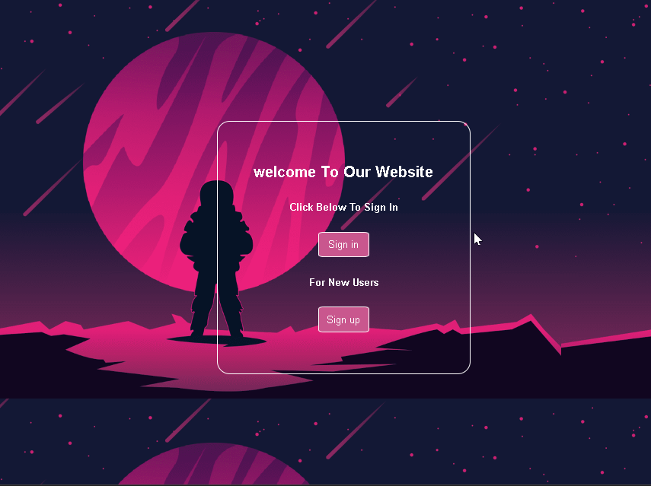

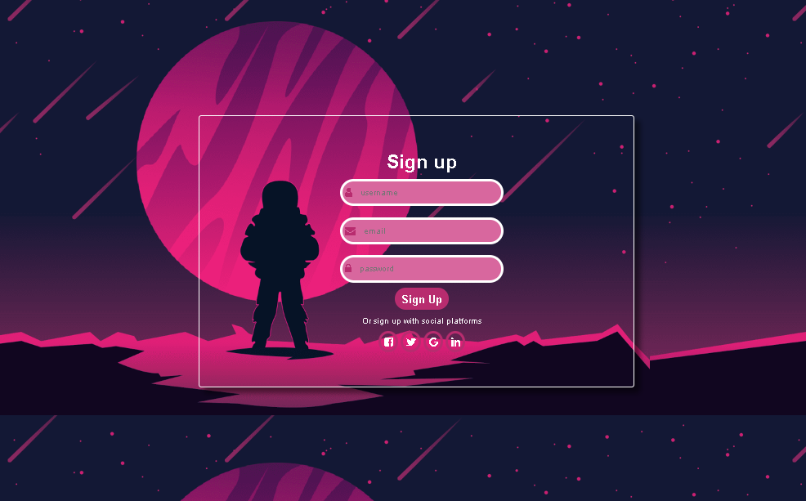 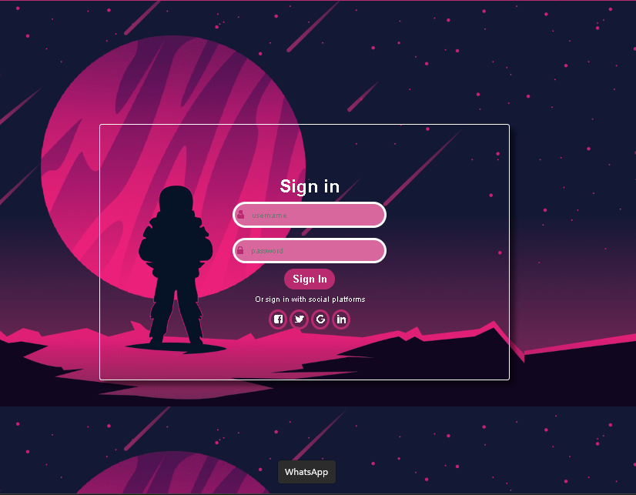

**SIGN UP PAGE SIGN IN PAGE**

8

CONCLUSION:

* A form of login authentication is an integral part of any system that requires secure user access. It allows users to securely access their account by verifying their identity with credentials such as username, password or two-factor authentication. The main features of the login authentication form are user identification, password field, remember me, forgotten password, two-factor authentication, captcha, social login, secure connection, account lock and multi-factor authentication. The login authentication form offers many benefits such as security, personalization, accountability, collaboration, personalization and compliance. By implementing a strong and reliable form of login authentication, organizations can ensure a secure and efficient user experience for their users.